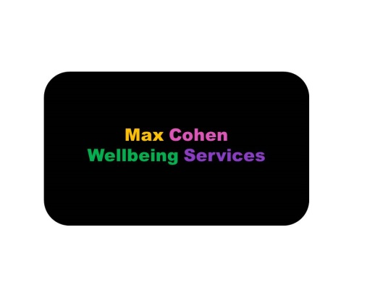
Testimonials from 2020

Work with clients

“Thank you so much. My time/work with you has benefited me in such unexpected ways - I didn’t know I’d learn so much about myself in such a short time or even that there was so much to discover.“

“For now I’m comfortable that I’ve reached a good point to move forwards from. It’s not the clarity I expected but, becoming “more stable” has given me a wonderful vantage point.”
“I’m not worried about the future - whatever happens it’ll be ok.”
“I can't offer any negative feedback! I'm more than happy with everything we achieved :-) On a positive note, one of the things that stood out to me was your style of listening and interaction. At times you'd just listen attentively but then there were times when you picked up on something key and became excited by the revelation. That helped me to open up - it felt as though we were both on the journey together.”
“What's been interesting to me is that I went into therapy for depression with the goal of getting out from under it. Before I first met with you I'd started to brainstorm what I wanted to get out of counselling, but in truth, I don't think I really had a fixed goal. I think I subconsciously knew I wanted to be in a different, better headspace and we got there.”

Talks and training - Working with LGBTQ+ clients
“I feel more confident, recognising from your talk, that there are a lot of overlaps with the way I work, such as self-compassion, re - framing and mindfulness.”
“I would recommend the “Working well with LGBTQ+ clients” 2 day on-line course to other professionals. I liked the combination of power point presentation, LGBT+ models and videos. It was clear and very informative but also very interesting and enjoyable.”
“It provided a safe environment in which to explore. The knowledge of the trainer was excellent and he was skilful in supporting our learning in the online environment.”
“I think it’s a very good introduction to understanding LGBT+ clients’ issues and how to support them through counselling.”
“This course is especially good for people who don’t know too much about LGBT+ people’s difficulties, LGBT+ models, and terminology as well as more positive, affirmative ways to help LGBT+ clients.”
“Also this course has helped me to understand more about myself and in the light of that how I can help my clients more on their journey. I have become more aware of how much prejudice there still is in relation to LGBT+ people and how this can also be part of my clients’ distress.”

Feel The Fear and Do It Anyway
“Max created a safe and accepting space in which everyone was valued and could be themselves. I feel uplifted after the session. It was supportive hearing other's reasons for coming to the talk.”
“I would recommend this to others”
“I enjoyed the talk a lot”

